Chemistry 260 Fall 2025

E11: Synthesis and Reactions of Diazonium Salts
<<This report will be completed as an “in-lab assignment” that you will work on and hand in at the end of the period. You can (and should!) do some of the work (e.g., the NMR analysis and questions that relate to them) in advance.>>

Name: ___________________________________Section:___________Date: ___________________________
Reaction Schemes (1 mark)

Observations (1 mark)

Reagents and Products Tables (1 marks; 0.5 marks each)
Table 1. Reagents for the reactions of diazonium salt
Compound | MW (g/mol) | Used | mmol | Physical and Safety Data
sulfuric acid (conc.) | 98.8 | 1.5 mL | 26.8 | Highly toxic; corrosive. 18M is 96% by weight in water; density is 1.84 g.ml⁻¹
4-nitroaniline | 138.12 |  |  | Toxic, mp 146-149 °C
sodium nitrite | 69.00 |  |  | Toxic; oxidizer
potassium iodide | 166.00 |  |  | Irritant
ethanol | 46.07 | ~10 mL | N/A | Flammable liquid; irritant. Bp 78o; density 0.789 g/mL.
2-naphthol | 144.17 |  |  | Corrosive, irritant, toxic. Mp 120-122 °C
2.5 M sodium hydroxide | 40.00 | 10 mL | N/A | Toxic; corrosive.
1 M sulfuric acid | 98.8 | minimal | N/A | Highly toxic; corrosive.

Table 2. Products of the reactions of diazonium salt
Compound | Physical Description | MW (g/mol) | Amount Isolated | mmol | % yield
1-iodo-4-nitrobenzene |  | 249.01
para red |  | 293.28

Results
Percent Yield Calculation: (1 mark)

Melting Range: (1 mark)
Table 3. Melting range analysis of the product of reaction with potassium iodide
Melting Range | Inferred Analysis (Compound identity, purity)

Results of Acid/Base Behaviour Analysis for Para Red: (3 mark)
Table 4. Colour and major species in aqueous media
Solution | Colour of Solution | Structure of Species
distilled water
0.1 M hydrochloric acid
0.1 M sodium hydroxide
In-lab Assignment Questions:
Use the attached ¹H NMR and ¹H-¹H COSY data to complete the NMR analysis table below (4 marks):

Table 5. ¹H and ¹H-¹H COSY NMR Data
chemical shift, δ (ppm) | multiplicity | coupling constant (Hz) | integration |  | assignment | Coupled to (COSY)
chemical shift, δ (ppm) | multiplicity | coupling constant (Hz) | actual | relative | assignment | Coupled to (COSY)
8.43 | d | 7 | 1.00 | 1.00 | H_{f}
8.34 | AA'BB' | - | 2.05
7.72-7.68 | m | - | 2.91
7.59-7.42 | m | - | 2.13
7.45 | ddd | 8 & 7 & 1 | 1.01
7.27 | s | - | -
6.71 |  |  | 0.94
Labelled structure:

Provide a brief justification of how you assigned the peaks in the ¹H NMR and ¹H-¹H COSY spectra. (4 marks)

Comment on the effect of adding the para red to aqueous solutions of different pH values. What is the chemical basis of the difference(s) in colour? What approximate wavelength of light (in nm) is absorbed in each solution? Relate the change in wavelength to structure of the species present at each pH. Refer to page 25 of your lab manual for a nice colour wheel diagram. (3 marks)

Based on the behaviour in aqueous solution at different pH values, what is a potential application of para red? (1 mark)

Appendix A: ¹H NMR of para red
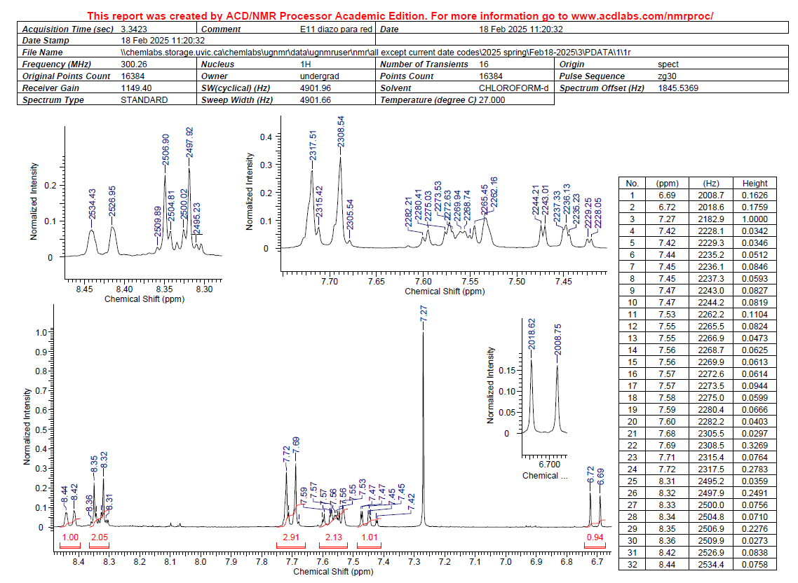

Appendix B: ¹H-¹H COSY NMR of para red
